# Lab 16 notes:

# Author: Khang Trinh – 102118468

Q1: Official site: <https://www.libsdl.org/>

Q2: SDL = Simple Directmedia Layer

Q3: Released under the zlib license <https://www.zlib.net/zlib_license.html>

Q4: Supports windows, mac, linux, ios and android

Q5: Written in C <https://www.libsdl.org/index.php>

Q6: Where to look for API by Name <http://wiki.libsdl.org/CategoryAPI>

Q7: I couldn’t find where they explain the different options, but here’s my assumptions:

* Source Code: The source code of the for people who wanna work on the library itself
* Runtime Binaries: Code for running games that use this library
* Dev Libraries: Code for game devs to use for making their games

Q8: I’m a student learning how to make a game using this library, so the 3rd option above

Q9: Difference between a library and a framework:

* A library: a *library* of code that the user can choose and use wherever, whenever they need to solve their problem
* A framework: provides code as a *frame*/a guide for the user on how to solve their problem
* The programmer has more freedom when using a library than a framework.

<https://www.freecodecamp.org/news/the-difference-between-a-framework-and-a-library-bd133054023f/>

Q10:

* Configuration & Platform need to be changed to “All Platforms”
* Active solution platform needs to be x64
* The current language configuration needs to include the library
* The linker’s additional library needs to include x64
* The linker’s input needs to have SDL2.lib and SDL2main.lib dependencies

Q11: Links used for learning:

How to set up SDL2 and do basic coding to get a window appearing

<https://www.youtube.com/watch?v=QQzAHcojEKg&ab_channel=Let%27sMakeGames>

How to handle text input and keyboard input

<https://www.youtube.com/watch?v=m2doh3Li65c&ab_channel=CodingMadeEasy>

<https://www.youtube.com/watch?v=IetfLyHh3-g&ab_channel=CodingMadeEasy>

Key codes

<http://wiki.libsdl.org/SDL_Keycode>

How to quit using SDL

<https://stackoverflow.com/questions/15272089/sdl-event-loop-quitting>

Hello World code demo

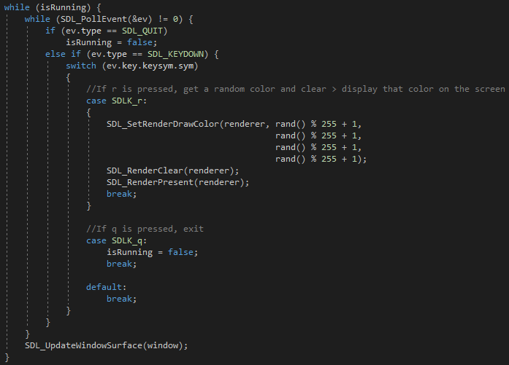

Fig . Main code that change colors on pressing "R" and quit on pressing "Q"

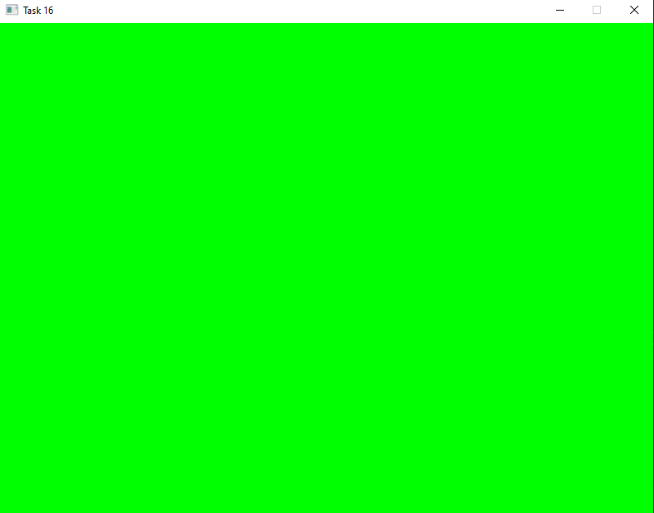

Fig . Initial window's appearance

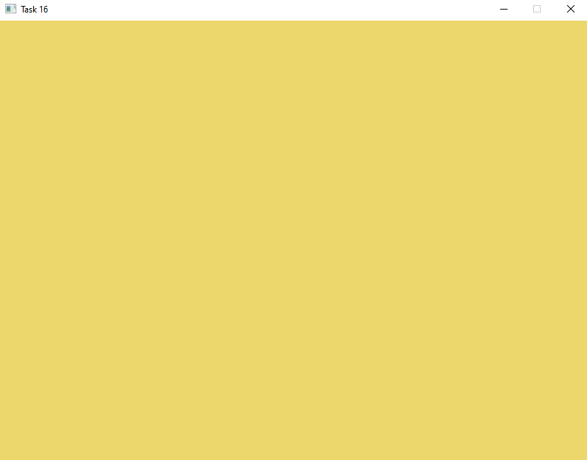

Fig . What happens after pressing "R"

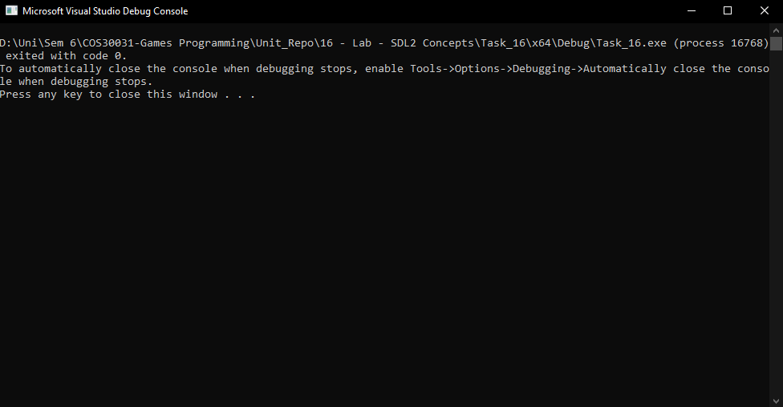

Fig . What the console log looks like